Remove Compensation permissions
Thursday, March 26, 2026
10:11 AM

Remove Executive Review from being editable and viewable from the managers
Permission group : FL Managers

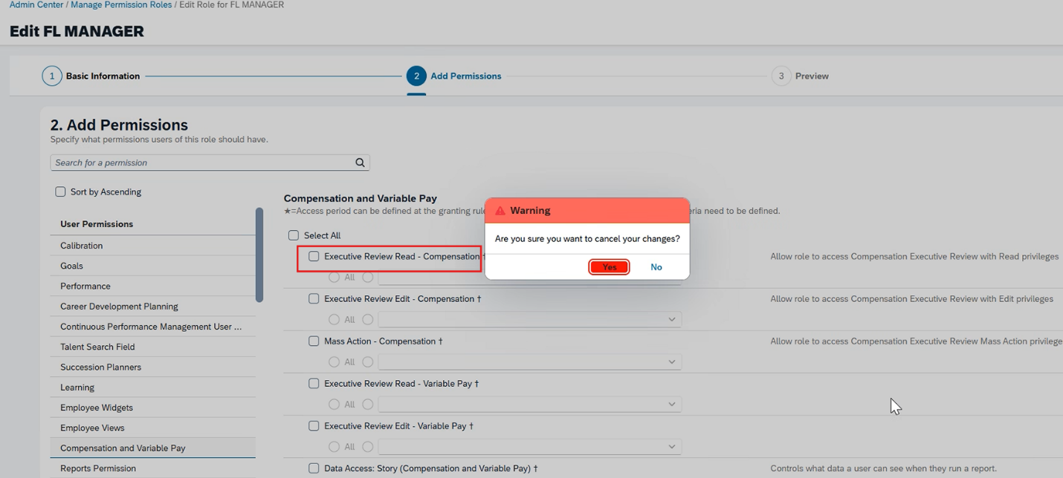

Lauren hays
Linda Gul

